SpaGene Analysis
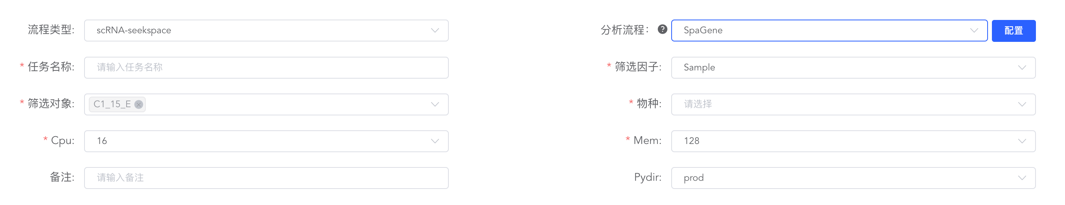
英文：
To infer intercellular communication networks within the tissue microenvironment, we performed ligand-receptor (L-R) co-localization analysis on the spatial transcriptomics data using the SpaGene algorithm ^{[1]}. First, a priori L-R interaction pairs were retrieved from the CellChatDB database, and a spatial nearest-neighbor graph was constructed based on the physical coordinates of the spots in the tissue sections. Subsequently, SpaGene employed graph convolution operations to integrate the gene expression profiles of the central spot and its neighbors to mitigate dropout noise, and calculated the co-localization score in the local microenvironment by evaluating the smoothed L-R expression levels. To determine the statistical significance of the interactions, the spatial coordinates were randomly permuted 1000 times to generate a background null distribution. Finally, L-R interaction pairs with significant spatial co-localization patterns were identified and spatially visualized.

中文：
为了推断组织微环境中的细胞间通讯网络，我们利用 SpaGene 算法在空间转录组数据中进行了配体-受体（L-R）共定位分析^{[1]}。首先，我们基于 CellChatDB 数据库获取了先验的 L-R 互作对，并根据空间切片中 spots 的物理坐标构建了空间邻接图。随后，SpaGene利用图卷积操作整合了中心 spot 及其邻域的基因表达谱以克服 dropout 噪声，并通过评估平滑后的 L-R 表达量计算了局部微环境中的共定位得分。为了确定互作的统计学显著性，我们对空间坐标进行了 1000 次随机置换以生成背景零分布，最终筛选出具有显著空间共定位模式的 L-R 互作对并进行了空间可视化。

[1] LIU Q, HSU C Y, SHYR Y. Scalable and model-free detection of spatial patterns and colocalization[J]. Genome Research, 2022.

