CellCharter Analysis
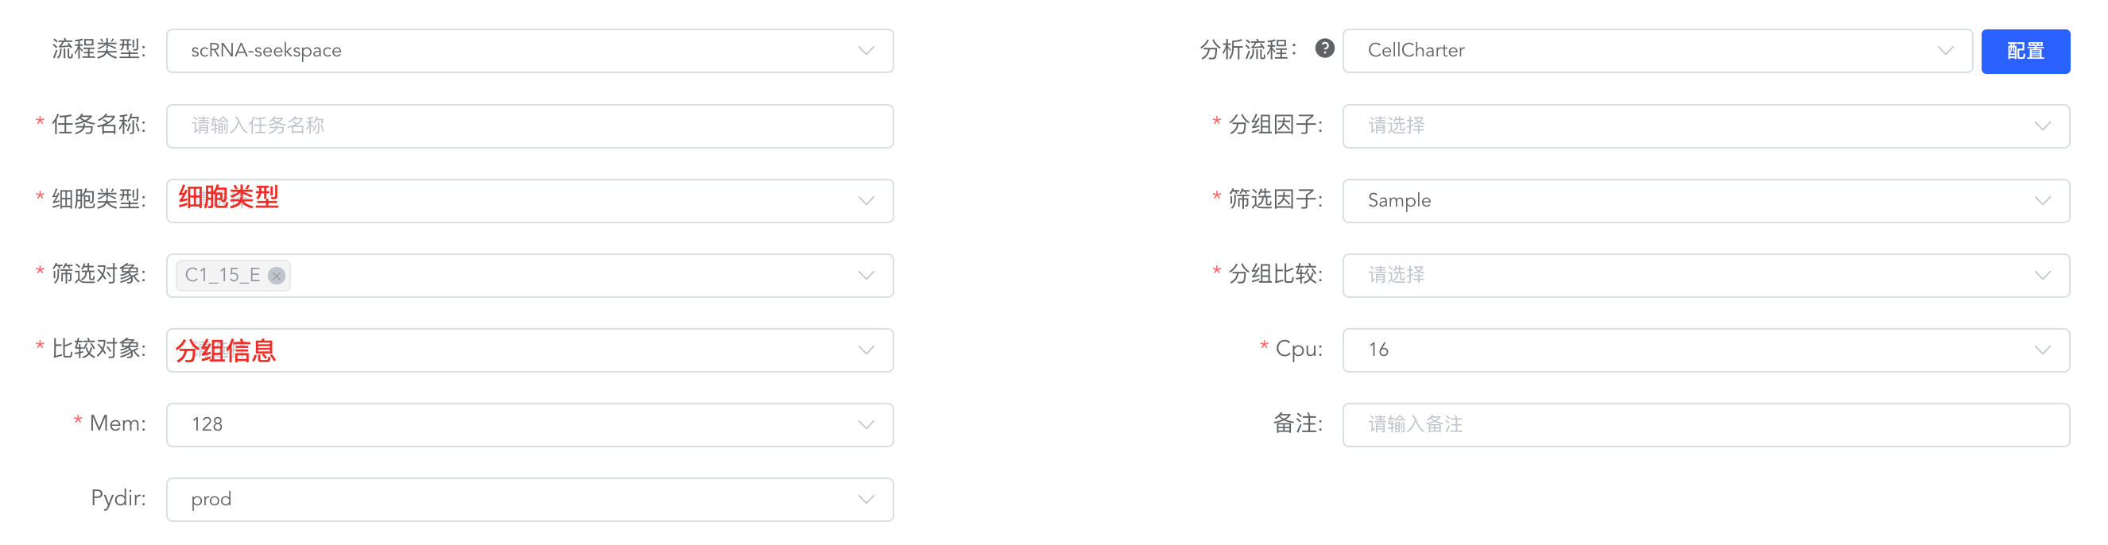
英文：
To elucidate the spatial organization of cells within the tissue microenvironment, we performed cell type co-localization analysis using the CellCharter algorithm ^{[1]}. First, a spatial neighborhood graph was constructed based on the physical coordinates of the cells in the tissue sections, with spatial neighborhoods defined via Delaunay triangulation. To evaluate the spatial co-localization relationships between different cell types, we counted the observed frequency of a target cell type within the neighborhood of a central cell type. A null distribution was established by randomly permuting the spatial labels 1000 times to calculate the expected background frequency. The log2 fold change (Log2FC) between the observed and expected frequencies was defined as the spatial enrichment score, where a positive value indicates spatial clustering and a negative value indicates spatial avoidance. Furthermore, to reveal the remodeling of spatial architectures under different pathological states, we calculated the co-localization scores within each experimental group separately. Statistical tests (e.g., Wilcoxon rank-sum test) were then applied to compare the differences in enrichment scores between groups, ultimately identifying and visualizing spatial interaction patterns that were significantly altered under specific conditions.

中文：
为了解析组织微环境中的细胞空间排布规律，我们采用 CellCharter 算法进行了细胞类型共定位分析^{[1]}。首先，基于空间切片中细胞的物理坐标构建了空间邻接网络（通过 Delaunay 三角剖分定义空间邻域）。为了评估不同细胞类型间的空间共定位关系，我们统计了中心细胞邻域内出现目标细胞类型的实际频次，并通过对空间标签进行 1000 次随机置换建立零分布以获取预期背景频次。观测频次与预期频次比较得出的 log2 倍数变化（Log2FC）被定义为空间富集得分，正值代表空间聚集，负值代表空间排斥。进一步地，为了揭示不同病理状态下的空间结构重塑，我们分别计算了各实验组内的共定位得分，并通过统计学检验（如 Wilcoxon 秩和检验）比较了组间富集得分的差异，最终筛选并可视化了在特定条件下发生显著改变的细胞空间互作模式。

[1] VARRONE M, TAVERNARI D, SANTAMARIA-MARTÍNEZ A, et al. CellCharter reveals spatial cell niches associated with tissue remodeling and cell plasticity[J]. Nat Genet, 2024, 56: 74–84.

