MISTy Analysis
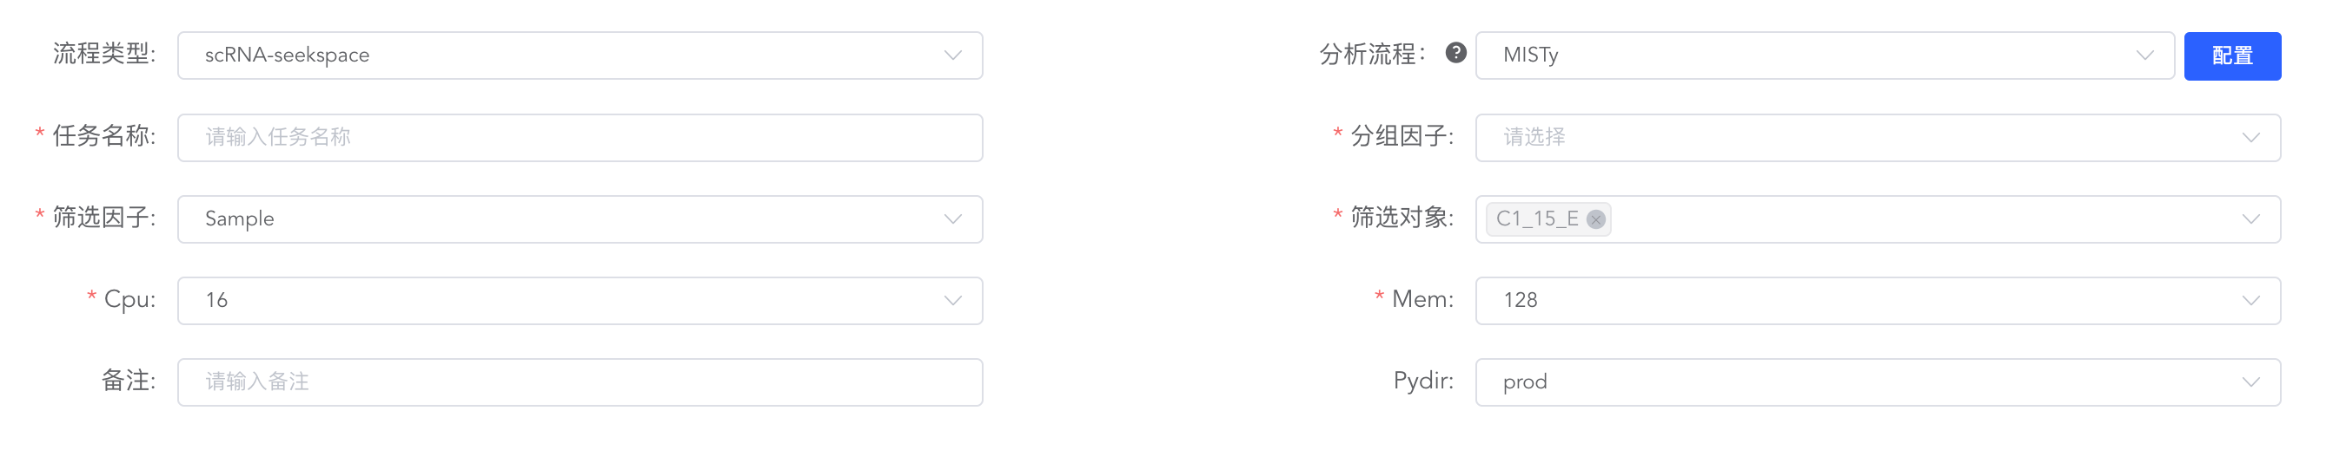
英文：
To systematically evaluate the regulatory effects of the spatial microenvironment on cell states and gene expression, we employed the MISTyR framework to construct spatial multiview machine learning models ^{[1]}. This analysis decomposes the prediction of target features into multiple independent views representing different spatial contexts. Initially, we defined an intrinsic view reflecting the cell's own state, and constructed a paraview (Juxtacrine/Paracrine view) based on the physical coordinates of the cells to capture local intercellular communication, defined by a specific spatial distance radius. Subsequently, MISTyR utilized a Random Forest algorithm to train predictive models for each view separately, and integrated the predictions to quantify the relative contribution importance of different spatial scales (e.g., intrinsic vs. neighborhood) to target gene expression. By extracting the feature importance scores from the models, we inferred the driving relationships of specific microenvironmental signals (such as the abundance of neighboring cell types or the expression of specific molecules) on the transcriptional state of the central cell, thereby uncovering the complex and spatially restricted intercellular regulatory networks within the tissue.

中文：
为了系统性评估空间微环境对细胞状态和基因表达的调控作用，我们采用了 MISTyR 框架构建了空间多视图机器学习模型^{[1]}。该分析将目标特征的预测分解为不同空间上下文的多个独立视图（Views）。首先，我们定义了反映细胞自身状态的内在视图（Intrinsic view），并基于细胞的物理坐标构建了反映局部细胞间通讯的近邻空间视图（Juxtacrine/Paracrine view，通过设定特定的空间距离半径提取）。随后，MISTyR 采用随机森林算法对每个视图分别训练预测模型，并将各视图的预测结果进行整合，以量化不同空间尺度（如自身 vs. 邻域）对目标基因表达的相对贡献重要性。通过提取模型中各特征的重要性评分，我们推断了特定的微环境信号对中心细胞转录状态的驱动关系，从而揭示了组织中复杂且空间受限的细胞互作调控网络。

[1] TANEVSKI J, FLORES R O R, GABOR A, et al. Explainable multiview framework for dissecting spatial relationships from highly multiplexed data[J]. Genome Biol, 2022, 23: 97.

