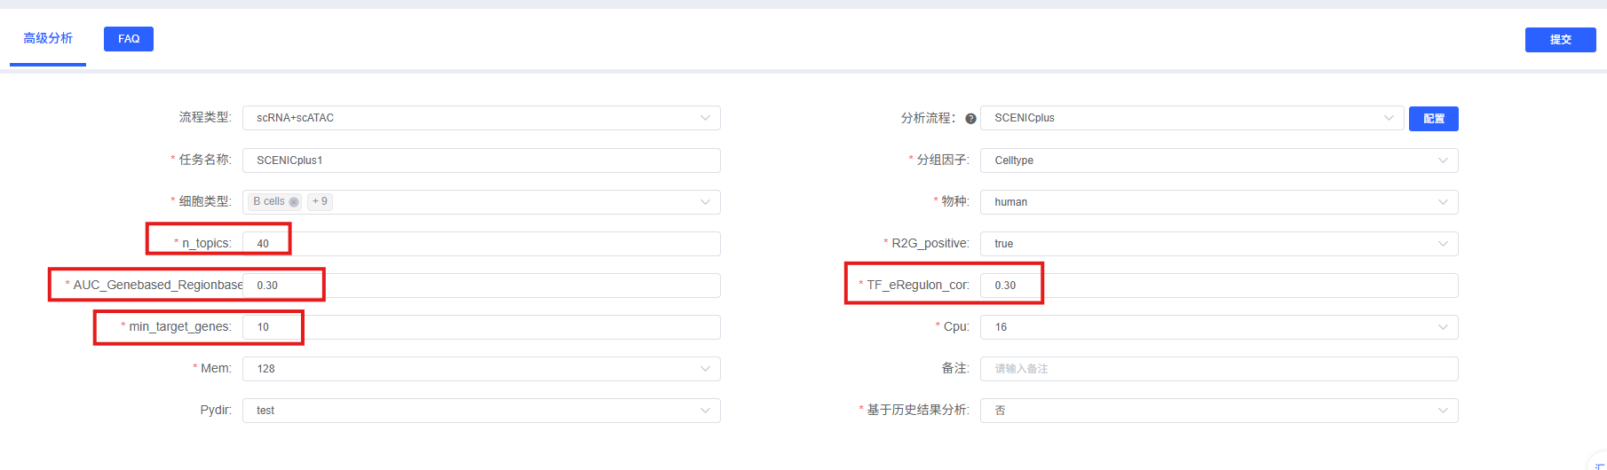
SCENIC+ regulatory network inference. To reconstruct transcription factor (TF)–mediated gene regulatory networks from single-cell multiomic data (scRNA-seq + scATAC-seq), regulatory network inference was performed using SCENIC+ [1]. The analysis was conducted in four sequential steps. First, ATAC peak counts were subjected to latent Dirichlet allocation (LDA) topic modeling via pycisTopic [2] to identify co-accessible regulatory modules and define consensus regions. Second, a custom cisTarget motif scoring database was constructed by scanning consensus regions with the Cluster Buster motif scanner against the species-specific motif collection, generating motif enrichment rankings and scores. Third, the SCENIC+ pipeline integrated RNA expression data (for TF–gene co-expression inference) and ATAC accessibility data (for motif enrichment and chromatin accessibility constraints) to infer TF–cis-regulatory element–target gene relationships, producing extended regulons (eRegulons) annotated with activation/repression directionality. Fourth, AUCell was used to compute per-cell activity scores (AUC) for each eRegulon based on its target gene set and associated cis-regulatory regions.

eRegulon quality filtering and regulon specificity scoring. To ensure high-confidence regulatory connections, eRegulons were filtered using three criteria: (i) the absolute Pearson correlation between TF expression and eRegulon AUC score exceeding【TF_eRegulon_cor】; (ii) the Pearson correlation between gene-based and region-based AUC scores exceeding 【AUC_Genebased_Regionbased_cor】, confirming consistency across RNA and ATAC modalities; and (iii) a minimum of 【min_target_genes】target genes per eRegulon. For each retained eRegulon, regulon specificity scores (RSS) were computed across cell types to identify cell-type-specific regulatory programs. RSS quantifies the degree to which an eRegulon's activity is enriched in a given cell type relative to all others.

References
[1] van de Sande B, Fanti VL, Huynh-Thu VA, et al. SCENIC+: single-cell multiomic inference of enhancers and gene regulatory networks. Nature Methods, 2023, 20(8): 1154-1164.
[2] Bravo Gonzalez-Blas C, Minnoye I, Papasokrati D, et al. cisTarget: performing cis-regulatory motifs identification. Nature Methods, 2019.

