NicheNet_spatial Analysis
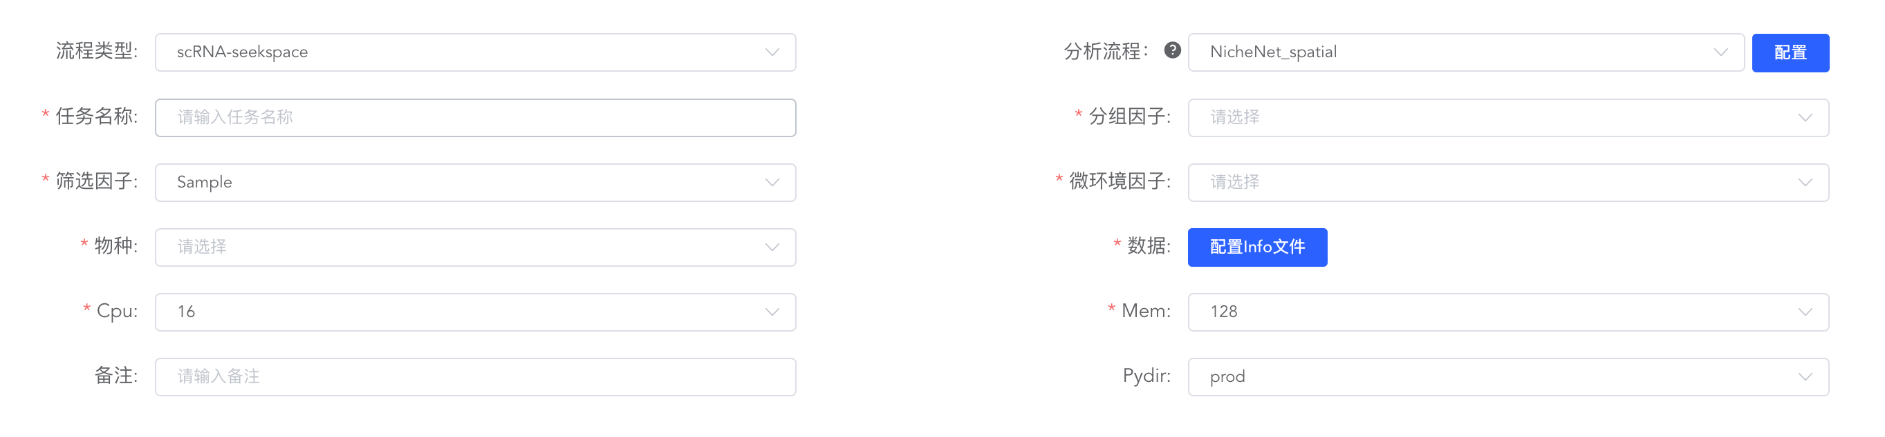
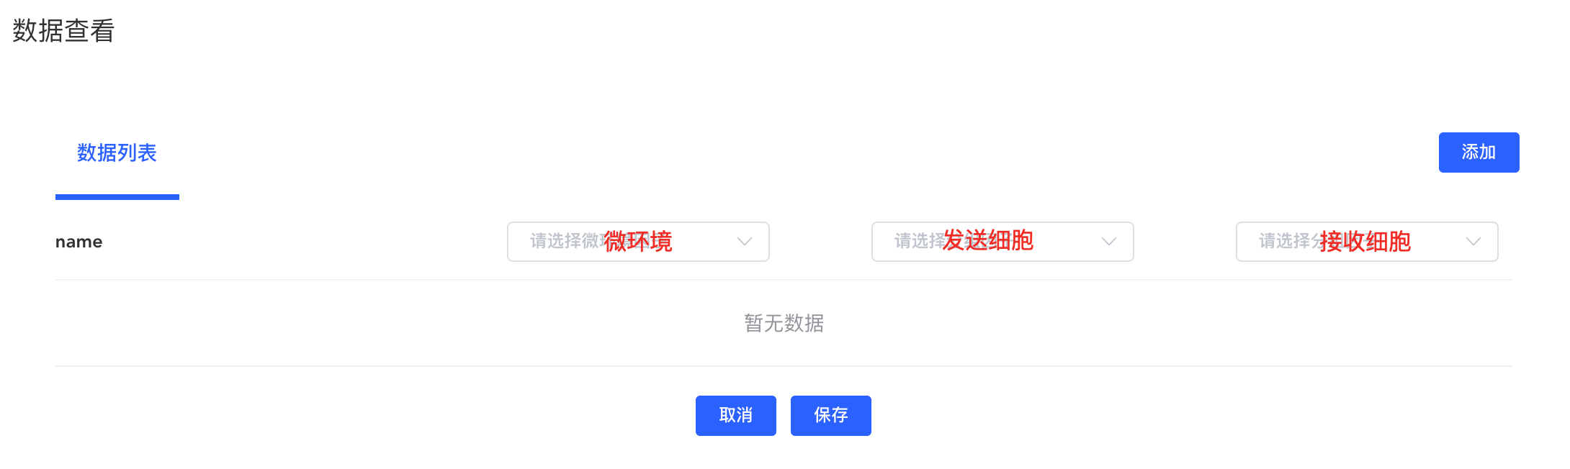

英文：
To elucidate how intercellular communication drives downstream gene expression reprogramming within specific tissue microenvironments, we applied the NicheNet algorithm to the spatial transcriptomics data ^{[1]}. Initially, by combining spatial coordinates with cell type annotations, we defined specific spatial niches and specified the signal sender and receiver cells within these regions. Subsequently, characteristic response genes of the receiver cells in this microenvironment were extracted via differential expression analysis to serve as the "gene set of interest." NicheNet then integrated its built-in prior knowledge networks of ligand-receptor interactions, signal transduction, and gene regulation to evaluate the predictive ability of all potential ligands expressed by the sender cells on this target gene set. By calculating the Pearson correlation coefficient, we ranked the regulatory activity of the ligands and identified high-activity ligands. Finally, a "ligand-receptor-target gene" regulatory network was constructed, and the co-localization of high-activity ligands and their target genes was validated on the spatial sections, thereby revealing the key molecular mechanisms driving the remodeling of the spatial microenvironment.

中文：
为了解析特定组织微环境中细胞通讯如何驱动下游基因表达重编程，我们采用了 NicheNet 算法对空间转录组数据进行分析^{[1]}。首先，我们结合空间坐标与细胞类型注释，定义了特定的空间微环境，并明确了微环境内的信号发送细胞（Sender cells）与接收细胞（Receiver cells）。接着，我们通过差异表达分析（或基于空间特征的基因集筛选）提取了接收细胞在该微环境下的特征响应基因作为“感兴趣的靶基因集”。随后，NicheNet 整合了内置的配体-受体、信号转导和基因调控先验知识网络，评估了发送细胞所表达的所有潜在配体对该靶基因集的预测能力。通过计算 Pearson 相关系数，我们对配体的调控活性进行了排序，筛选出高活性配体。最终，我们构建了“配体-受体-靶基因”调控网络图，并在空间切片上对高活性配体及其靶基因的表达进行了共定位验证，从而揭示了驱动空间微环境重塑的关键分子机制。

[1] Guilliams et al. Spatial proteogenomics reveals distinct and evolutionarily conserved hepatic macrophage niches. Cell (2022) doi:10.1016/j.cell.2021.12.018

