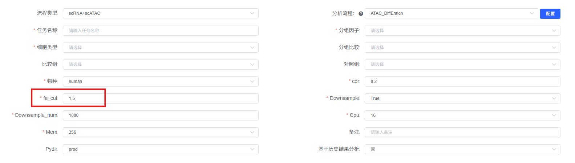
Differential chromatin accessibility analysis. To identify cell type-specific or condition-specific differentially accessible peaks, Wilcoxon rank-sum tests were performed using the presto R package [1] on the ATAC assay. Peaks with Benjamini-Hochberg adjusted p-value < 0.05 and log fold change > 0.25 were considered significantly differentially accessible.

Motif enrichment analysis. To identify transcription factors (TFs) potentially driving the observed chromatin accessibility changes, motif enrichment analysis was performed on the sets of differentially accessible peaks using the FindMotifs function from the Signac R package [2]. The analysis employed position frequency matrices from the JASPAR2020 database [3] and applied hypergeometric tests to assess enrichment significance. To reduce false positives arising from motif sequence enrichment without expression support, only motifs corresponding to TFs expressed in at least 10% of cells within the target cell population were retained. Motifs with adjusted p-value < 0.05 and fold enrichment > [fe_cut] were considered significantly enriched.

Peak-to-gene annotation. To link differentially accessible peaks to their putative target genes, each significant peak was annotated to its nearest genomic feature using the ClosestFeature function from Signac [2]. This nearest-neighbor approach assigns each peak to the closest gene based on genomic distance, providing candidate target genes for downstream functional enrichment analyses (GO and KEGG pathway analyses) using the clusterProfiler R package [4].

References
[1] Korsunsky I, Nathan A, Millard N, et al. Presto: Fast functions for differential expression using Wilcox and AUC. R package, 2019.
[2] Stuart T, Srivastava A, Madad S, et al. Single-cell chromatin state analysis with Signac. Nature Methods, 2021, 18(11): 1333-1341.
[3] Fornes O, Castro-Mondragon JA, Khan A, et al. The JASPAR 2020 release of the open-access database of transcription factor binding profiles. Nucleic Acids Research, 2020, 48(D1): D189-D192.
[4] Wu T, Hu E, Xu S, et al. clusterProfiler 4.0: A universal enrichment tool for interpreting omics data. iScience, 2021, 24(9): 103016.

