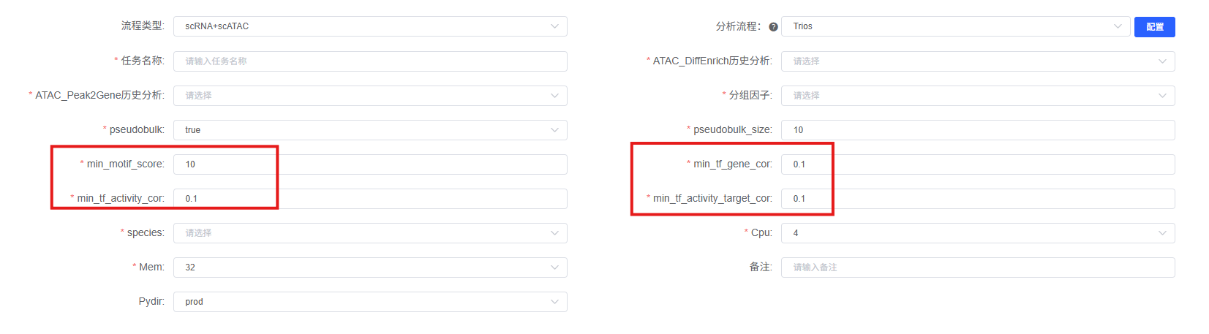
TF–Peak–Gene trios construction and filtering. To reconstruct the TF → Peak → Gene regulatory logic chains, a multi-dimensional filtering framework was applied to integrate four independent lines of evidence into a unified regulatory unit. First, initial TF–Peak–Gene trios were assembled by intersecting Peak-to-Gene co-variation links with Motif–Peak binding relationships through genomic spatial overlap analysis (findOverlaps), requiring that the TF's motif binding site physically resides within the target Peak region [1]. For each trios, four independent statistical tests were then performed: (i) Pearson correlation between TF mRNA expression and target gene expression (min_tf_gene_cor); (ii) Pearson correlation between TF chromVAR deviation score and TF mRNA expression (min_tf_activity_cor); (iii) Pearson correlation between TF chromVAR deviation score and target gene expression (min_tf_activity_target_cor); and (iv) motif binding affinity score at the Peak site. All three correlations were assessed with Benjamini-Hochberg correction (q < 0.05). A composite Linkage Score [2] was computed for each TF–Gene pair by summing the product of the squared Peak-to-Gene correlation coefficient (R²) and the motif binding score across all associated Peaks, quantifying the cumulative multi-site regulatory evidence. High-confidence trios were retained only when all four criteria were simultaneously satisfied: motif score above threshold, all three correlations significant with absolute values above threshold, and Linkage Score exceeding the 90th percentile of the genome-wide distribution.

References
[1] Anderson A G , Rogers B B , Loupe J M ,et al.Single nucleus multiomics identifies ZEB1 and MAFB as candidate regulators of Alzheimer's disease-specific cis-regulatory elements[J].Cell genomics, 3(3):100263[2026-07-10].DOI:10.1016/j.xgen.2023.100263.

[2] Ober-Reynolds B , Wang C , Ko J ,et al.Integrated single-cell chromatin and transcriptomic analyses of human scalp identify gene-regulatory programs and critical cell types for hair and skin diseases.[J].Nature genetics, 2023.DOI:10.1038/s41588-023-01445-4.

